Day 28 – Feature Representation

Bag of words :

In Natural Language Processing (NLP), text data must be converted into numerical form so that machine learning algorithms can process it. The Bag of Words (BoW) model is a simple and commonly used method for this purpose.
- Converts text (sentence, paragraph, or document) into a collection of words
- Counts how often each word appears in the text
- Ignores word order and grammar, focusing only on frequency
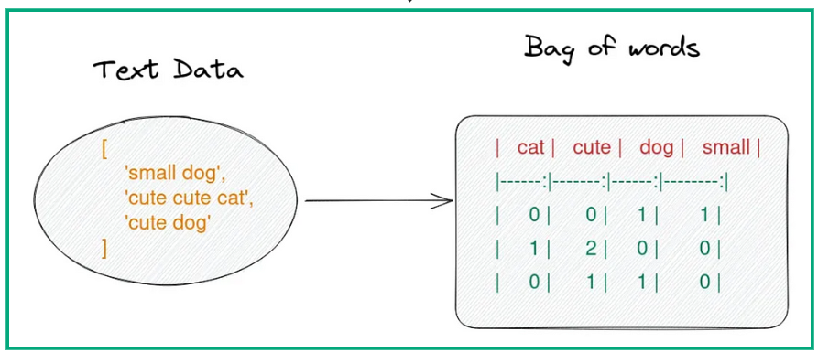

Key Components of BoW

- Vocabulary: It is a list of all unique words from the entire dataset. Each word in the vocabulary corresponds to a feature in the model.
- Document Representation: Each document is represented as a vector where each element shows the frequency of the words from the vocabulary in that document. The frequency of each word is used as a feature for the model.

Advantages
- Simplicity: It is easy to implement and computationally efficient.
- Versatility: It can be used for various NLP tasks such as text classification, sentiment analysis and document clustering.
- Interpretability: The resulting vectors are interpretable which makes it easy to understand which words are most important in a document.

Limitations
- Loss of Context: It ignores word order and context which means it might miss important relationships between words.
- Sparsity: When working with large datasets, most word vectors will be sparse (containing mostly zeros) which can lead to inefficiency.
- Limited Semantic Understanding: The model doesn’t capture the meaning of words which can be important for some NLP tasks.
TF-IDF (Term Frequency–Inverse Document Frequency)
It is a statistical method used in natural language processing and information retrieval to evaluate how important a word is to a document in relation to a larger collection of documents. TF-IDF combines two components:
1. Term Frequency (TF): Measures how often a word appears in a document. A higher frequency suggests greater importance. If a term appears frequently in a document, it is likely relevant to the document’s content.
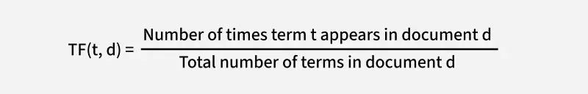
Term Frequency (TF)
2. Inverse Document Frequency (IDF): Reduces the weight of common words across multiple documents while increasing the weight of rare words. If a term appears in fewer documents, it is more likely to be meaningful and specific.
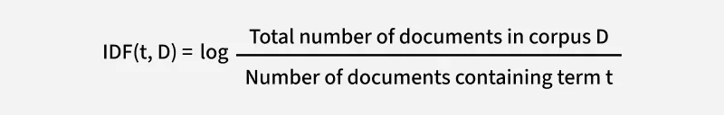
Inverse Document Frequency (IDF)
This balance allows TF-IDF to highlight terms that are both frequent within a specific document and distinctive across the text document, making it a useful tool for tasks like search ranking, text classification and keyword extraction.

Converting Text into vectors with TF-IDF
Let's take an example where we have a corpus (a collection of documents) with three documents and our goal is to calculate the TF-IDF score for specific terms in these documents.
- Document 1: "The cat sat on the mat."
- Document 2: "The dog played in the park."
- Document 3: "Cats and dogs are great pets."
Our goal is to calculate the TF-IDF score for specific terms in these documents. Let’s focus on the word "cat" and see how TF-IDF evaluates its importance.

Step 1: Calculate Term Frequency (TF)
For Document 1:
- The word "cat" appears 1 time.
- The total number of terms in Document 1 is 6 ("the", "cat", "sat", "on", "the", "mat").
- So, TF(cat,Document 1) = 1/6
For Document 2:
- The word "cat" does not appear.
- So, TF(cat,Document 2)=0.
For Document 3:
- The word "cat" appears 1 time.
- The total number of terms in Document 3 is 6 ("cats", "and", "dogs", "are", "great", "pets").
- So TF (cat,Document 3)=1/6
In Document 1 and Document 3 the word "cat" has the same TF score. This means it appears with the same relative frequency in both documents. In Document 2 the TF score is 0 because the word "cat" does not appear.

Step 2: Calculate Inverse Document Frequency (IDF)
- Total number of documents in the corpus (D): 3
- Number of documents containing the term "cat": 2 (Document 1 and Document 3).
IDF(cat,D)=log3/2≈0.176

Step 3: Calculate TF-IDF
The TF-IDF score for "cat" is 0.029 in Document 1 and Document 3 and 0 in Document 2 that reflects both the frequency of the term in the document (TF) and its rarity across the corpus (IDF).
The TF-IDF score is the product of TF and IDF:
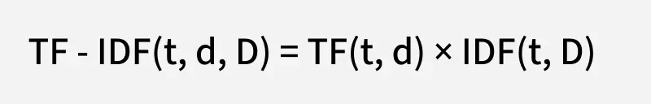

TF-IDF
- For Document 1: TF-IDF (cat, Document 1, D)-0.167 * 0.176 - 0.029
- For Document 2: TF-IDF(cat, Document 2, D)-0x 0.176-0
- For Document 3: TF-IDF (cat, Document 3, D)-0.167 x 0.176 ~ 0.029
Pros and Cons:
- Sparse matrix problem sorted.
- Semantic meaning (Word Relationship) Not Captured !
- Non - Vocabulary words dont have encoding.

Word Embeddings in NLP

Word Embeddings are numeric representations of words in a lower-dimensional space, that capture semantic and syntactic information. They play an important role in Natural Language Processing (NLP) tasks.
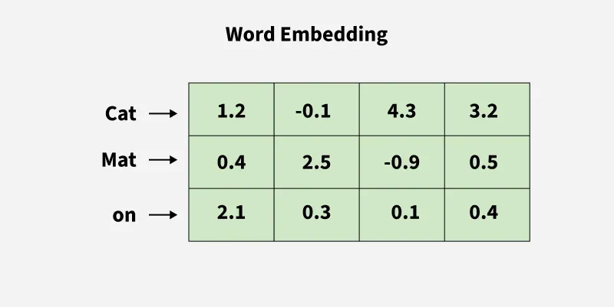

Need for Word Embedding?
- To reduce dimensionality.
- To use a word to predict the words around it.
- Helps in enhancing model interpretability due to numerical representation.
- Inter-word semantics and similarity can be captured.

Approaches for Text Representation

Traditional Approach

Neural Approach

Pretrained Word-Embedding

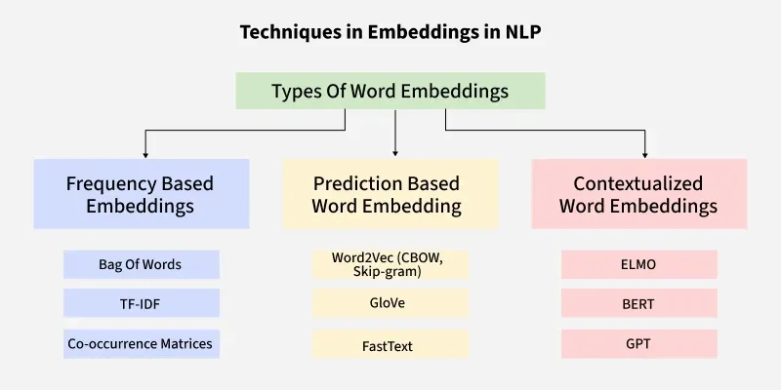

1. Traditional Approach
The conventional method involves compiling a list of distinct terms and giving each one a unique integer value or id, and after that, insert each word's distinct id into the sentence. Every vocabulary word is handled as a feature in this instance. Thus, a large vocabulary will result in an extremely large feature size. Common traditional methods include:
1.1 One-Hot Encoding
One-hot encoding is a simple method for representing words in natural language processing (NLP). In this encoding scheme, each word in the vocabulary is represented as a unique vector, where the dimensionality of the vector is equal to the size of the vocabulary. The vector has all elements set to 0, except for the element corresponding to the index of the word in the vocabulary, which is set to 1.
Following are the disadvantages:
- High-dimensional vectors, Computationally expensive and Memory-intensive
- Does not capture Semantic Relationships
- Restricted to the seen training vocabulary

1.2 Bag of Word (Bow)
Bag-of-Words (BoW) is a text representation technique that represents a document as an unordered set of words and their respective frequencies. It discards the word order and captures the frequency of each word in the document, creating a vector representation. Limitations are as follows:
- Ignores the order of words in the document: Causes loss of sequential information and context
- Sparse representations make it Memory intensive: Many elements are zero resulting in Computational inefficiency with large datasets.
1.3 Term frequency-inverse document frequency (TF-IDF)
Term Frequency-Inverse Document Frequency, commonly known as TF-IDF, is a numerical statistic that reflects the importance of a word in a document relative to a collection of documents (corpus). It is widely used in natural language processing and information retrieval to evaluate the significance of a term within a specific document in a larger corpus. TF-IDF consists of two components:
- Term Frequency (TF): Measures how often a term (word) appears in a document.
- Inverse Document Frequency (IDF): Measures the importance of a term across a collection of documents.
The higher the TF-IDF score for a term in a document, the more important that term is to that document within the context of the entire corpus.
Some of the disadvantages of TF-IDF are:
- Inability in Capturing context: Doesn't consider semantic relationships in words.
- Sensitivity to Document Length: Longer documents have higher overall term frequencies, potentially biasing TF-IDF towards longer documents.

2. Neural Approach
2.1 Word2Vec
Word2Vec is a neural approach for generating word embeddings. It belongs to the family of neural word embedding techniques and specifically falls under the category of distributed representation models. It is a popular technique in natural language processing (NLP).
- Represent words as continuous vector spaces.
- Aim: Capture the semantic relationships between words by mapping them to high-dimensional vectors.
- Words with similar meanings should have similar vector representations. Every word is assigned a vector. We start with either a random or one-hot vector.
There are two neural embedding methods for Word2Vec: Continuous Bag of Words (CBOW) and Skip-gram.
2.2 Continuous Bag of Words(CBOW)
Continuous Bag of Words (CBOW) is a type of neural network architecture used in the Word2Vec model. The primary objective of CBOW is to predict a target word based on its context, which consists of the surrounding words in a given window. Given a sequence of words in a context window, the model is trained to predict the target word at the center of the window.
- Feedforward neural network with a single hidden layer.
- The input layer, hidden layer, and output layer represent the context words, learned continuous vectors or embeddings, and the target word.
- Useful for learning distributed representations of words in a continuous vector space.
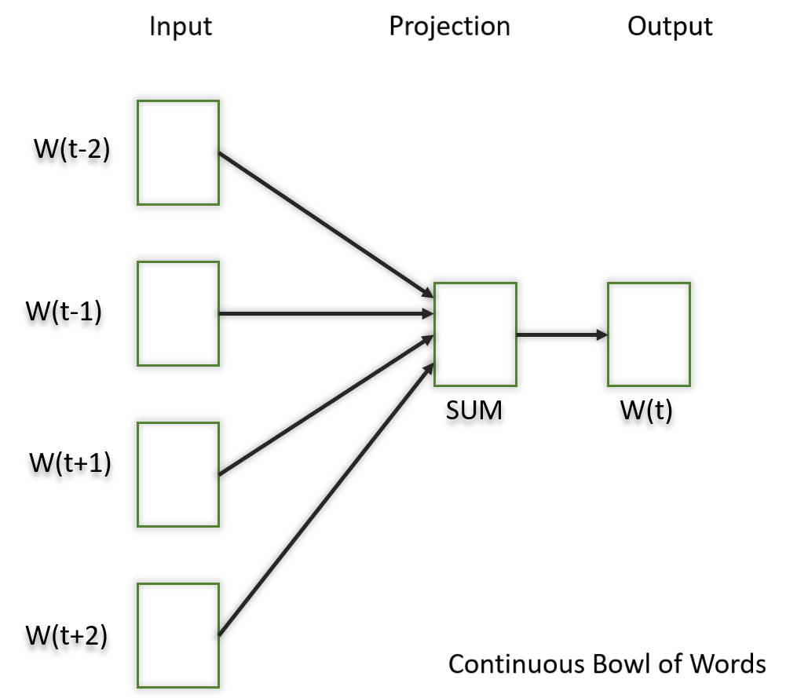
The hidden layer contains the continuous vector representations (word embeddings) of the input words.
- The weights between the input layer and the hidden layer are learned during training.
- The dimensionality of the hidden layer represents the size of the word embeddings (the continuous vector space).
​
2.3 Skip-Gram
The Skip-Gram model learns distributed representations of words in a continuous vector space. The main objective of Skip-Gram is to predict context words (words surrounding a target word) given a target word. This is the opposite of the Continuous Bag of Words (CBOW) model, where the objective is to predict the target word based on its context. It is shown that this method produces more meaningful embeddings.
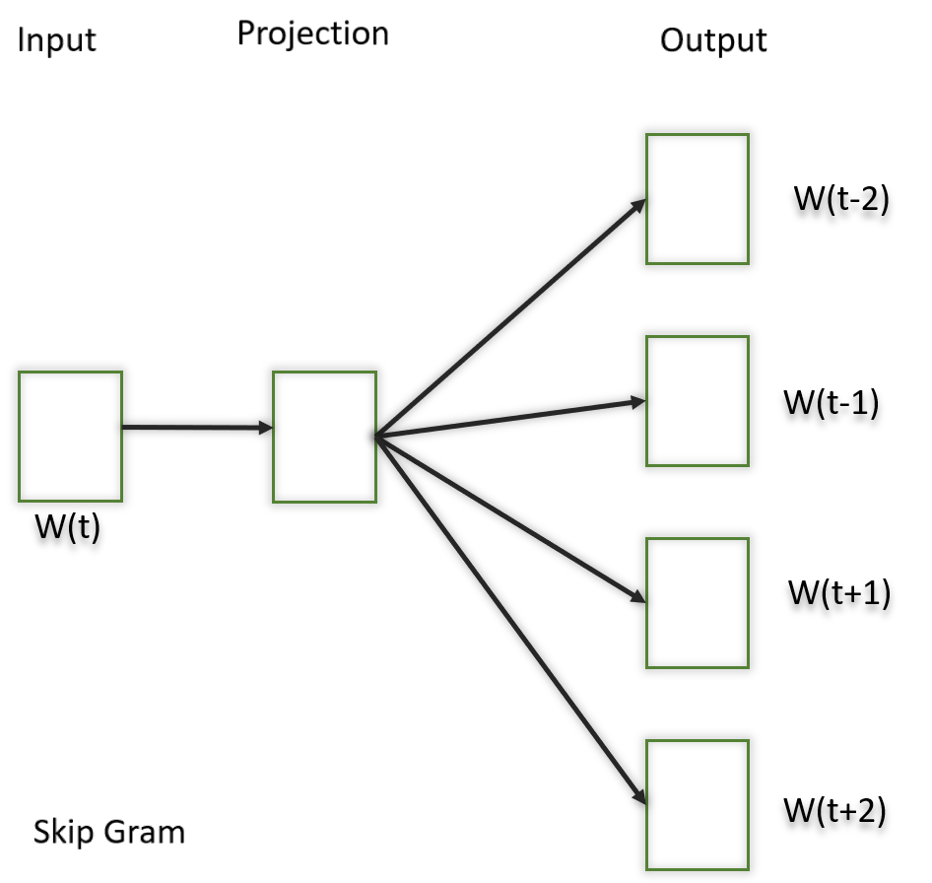
- Output: Trained vectors of each word after many iterations through the corpus.
- Preserve syntactical or semantic information, Converted to lower dimensions.
- Similar meaning (semantic info) vectors are placed close to each other in space.
- vector_size parameter controls the dimensionality of the word vectors, and you can adjust other parameters such as window.
The choice between CBOW and Skip-gram depends on data and the task.
- CBOW might be preferred when training resources are limited, and capturing syntactic information is important.
- Skip-gram is chosen when semantic relationships and the representation of rare words are important.

3. Pretrained Word-Embedding
Pre-trained word embeddings are representations of words that are learned from large corpora and are made available for reuse in various Natural Language Processing (NLP) tasks. These embeddings capture semantic relationships between words, allowing the model to understand similarities and relationships between different words in a meaningful way.
3.1 GloVe
GloVe is trained on global word co-occurrence statistics. It leverages the global context to create word embeddings that reflect the overall meaning of words based on their co-occurrence probabilities. this method, we take the corpus and iterate through it and get the co-occurrence of each word with other words in the corpus. We get a co-occurrence matrix through this. The words which occur next to each other get a value of 1, if they are one word apart then 1/2, if two words apart then 1/3 and so on.
Let's see how the matrix is created. Corpus:
It is a nice evening.
Good Evening!
Is it a nice evening?
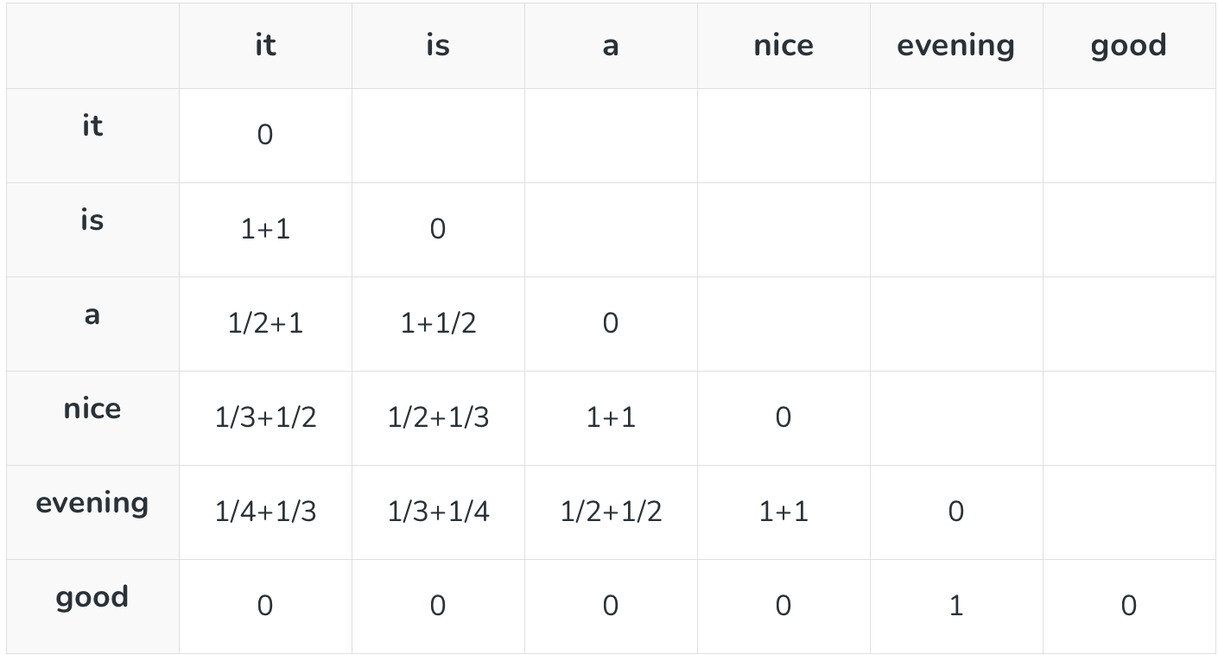
The upper half of the matrix will be a reflection of the lower half. We can consider a window frame as well to calculate the co-occurrences by shifting the frame till the end of the corpus. This helps gather information about the context in which the word is used.
- Vectors for each word is assigned randomly.
- Take two pairs of vectors and see closeness in space.
- If they occur together more often or have a higher value in the co-occurrence matrix and are far apart in space then they are brought close to each other.
- If they are close to each other but are rarely or not frequently used together then they are moved further apart in space.
- Output: Vector space representation that approximates the information from the co-occurrence matrix.
3.2 Fasttext
Developed by Facebook, FastText extends Word2Vec by representing words as bags of character n-grams. This approach is particularly useful for handling out-of-vocabulary words and capturing morphological variations.

3.3 BERT (Bidirectional Encoder Representations from Transformers)
BERT is a transformer-based model that learns contextualized embeddings for words. It considers the entire context of a word by considering both left and right contexts, resulting in embeddings that capture rich contextual information.

Advantages and Disadvantage of Word Embeddings

Advantages
- It is much faster to train than hand build models like WordNet
- Almost all modern NLP applications start with an embedding layer.
- It Stores an approximation of meaning.

Disadvantages
- It can be memory intensive.
- It is corpus dependent. Any underlying bias will affect your model.
- It cannot distinguish between homophones. E.g.: brake/break, cell/sell, etc.

